 

**Assignment – 4**

|  |  |
| --- | --- |
| **Student Name/ID Number:** | Wildan Luqmanul Hakim/BDSE04-0322 |
| **Academic Year:** | 2022 |
| **Unit Assessor:** | Arvinder Kaur |
| **Project Title:** | Assignment 4 - Spring Boot + JPA |
| **Issue Date:** | 28 November 2022 |
| **Submission Date:** | 29 November 2022 |
| **Internal Verifier Name:** |  |
| **Date:** | 29 November 2022 |

|  |
| --- |
| **Learner declaration** |
| I certify that the work submitted for this assignment is my own and research sources are fully acknowledged.    Student signature: Date: 29 November 2022 |

|  |  |  |  |  |  |
| --- | --- | --- | --- | --- | --- |
| **Module No:** | 1 | **IU No:** | 4 | **Exercise No.** | 1 |

|  |  |
| --- | --- |
| **Lab Assessment Statement** | **Assignment 4 - Spring Boot + JPA**  **Let’s build on the previous assignment.**   1. **Create a Spring Boot application for “Know-Your-Neighborhood”.** 2. **Add support for JSP views and create required folder structure.** 3. **Move already developed classes into this project.** 4. **Create store table in the database** 5. **Annotate all the fields of Store object appropriately.** 6. **Develop all components required to view the stores**    1. **Add method to existing Controller class to receive the request to fetch stores**    2. **Enhance Store service and Store Controller objects to support CRUD operations on store object.**    3. **Add method existing repository class to perform crud operations on Store object.**    4. **Create HTML to view the stores. Show name, phone number and localities it serves for each store.**    5. **Ensure that view stores request works end-to-end. (i.e., should be able to submit request to view the stores in the browser and get the page back with all stores).** 7. **Create an HTML page to perform Add store, Fetch stores, Update store, & Delete store operations from the UI.** |
| **Technical Environment** | - |
| **Guidelines** | - |
| **Duration** | 120 mins |

1. **Create a Spring Boot application for “Know-Your-Neighborhood”.**

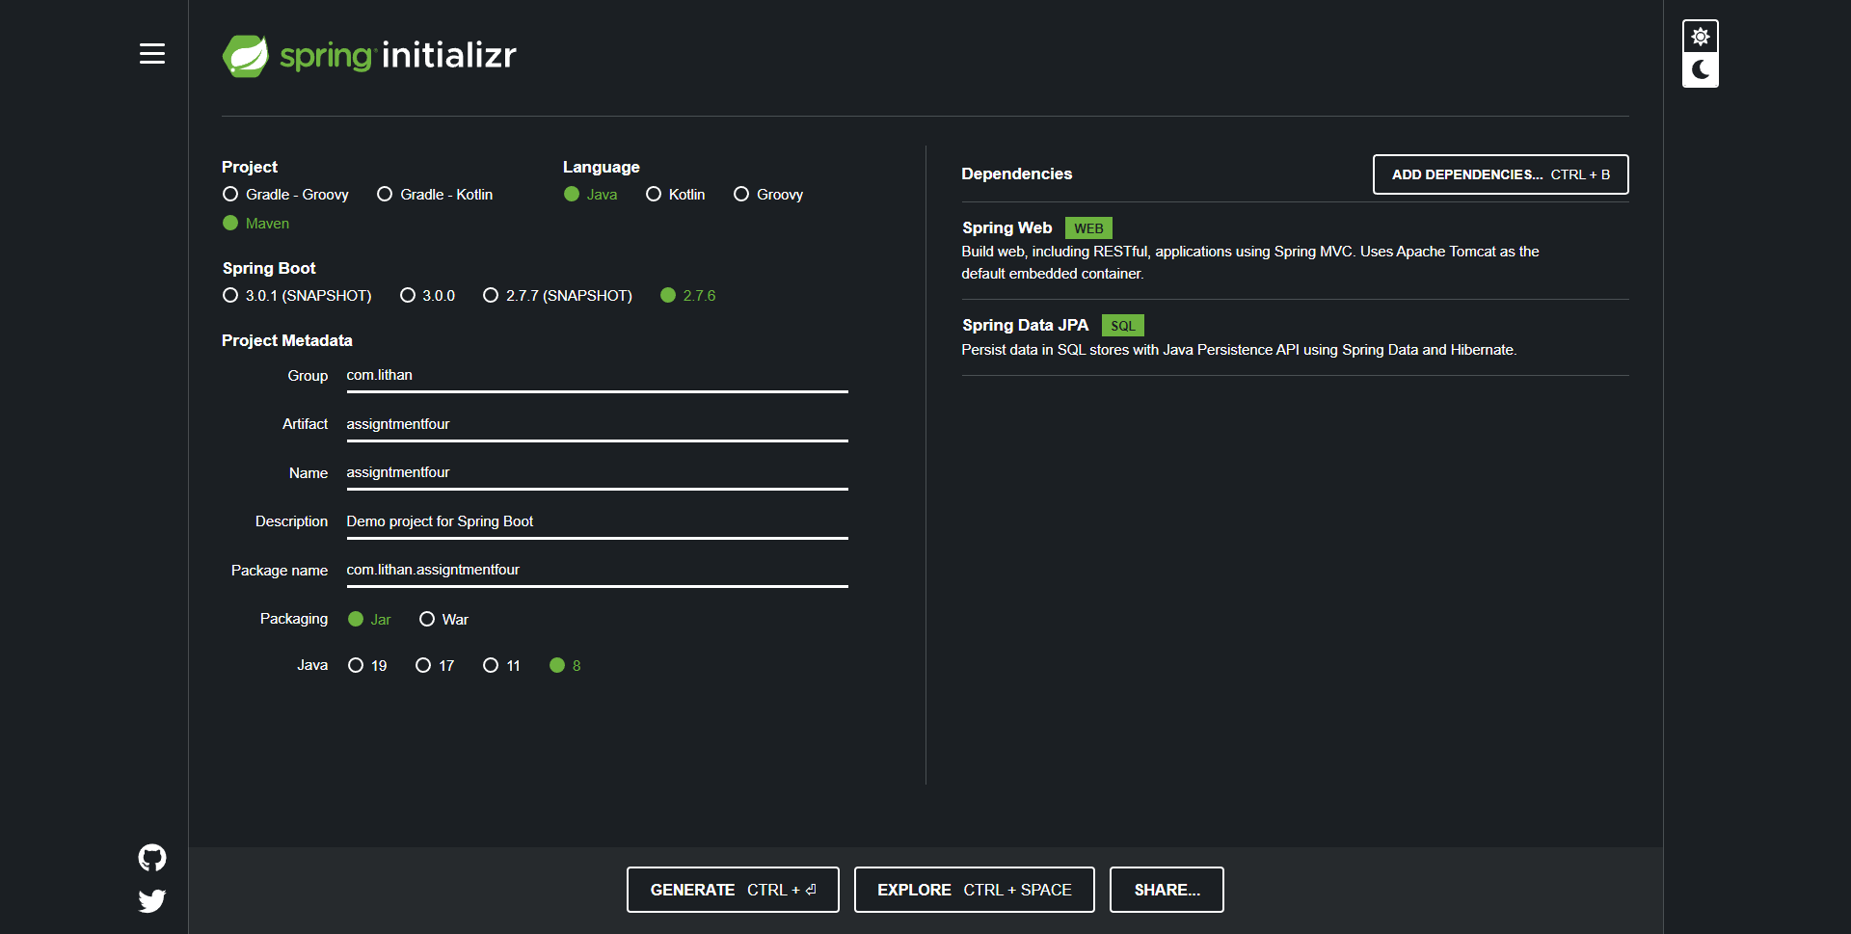

1. **Add support for JSP views and create required folder structure.  
   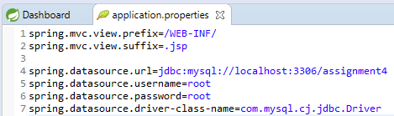**
2. **Move already developed classes into this project.  
   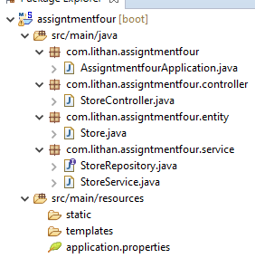**
3. **Create store table in the database  
   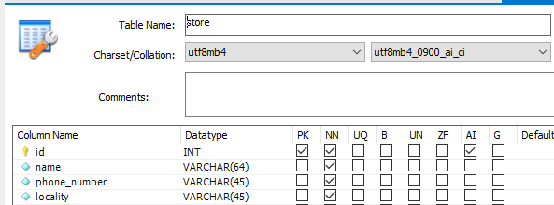**



1. **Annotate all the fields of Store object appropriately.   
   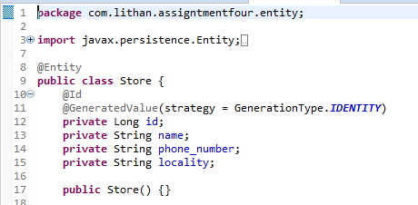**
2. **Develop all components required to view the stores**
   1. **Add method to existing Controller class to receive the request to fetch stores  
      StoreController.java  
      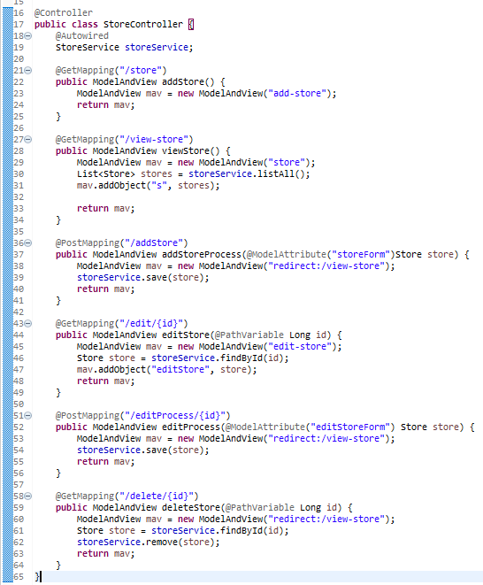**
   2. **Enhance Store service and Store Controller objects to support CRUD operations on store object.**

**StoreRepository.java  
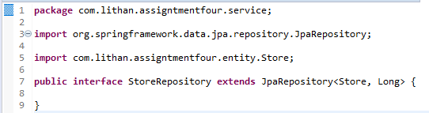**

**StoreService.java  
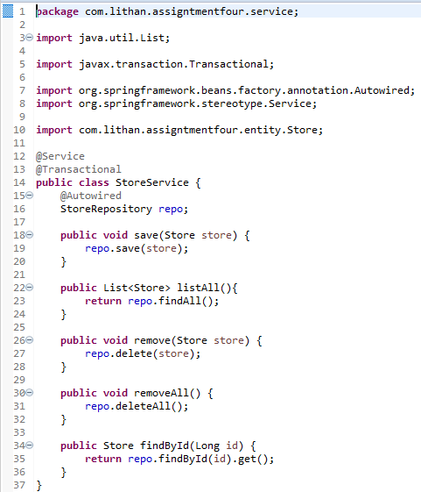**

* 1. **Add method existing repository class to perform crud operations on Store object.  
     StoreService.java  
     **
  2. **Create HTML to view the stores. Show name, phone number and localities it serves for each store.  
     store.jsp  
     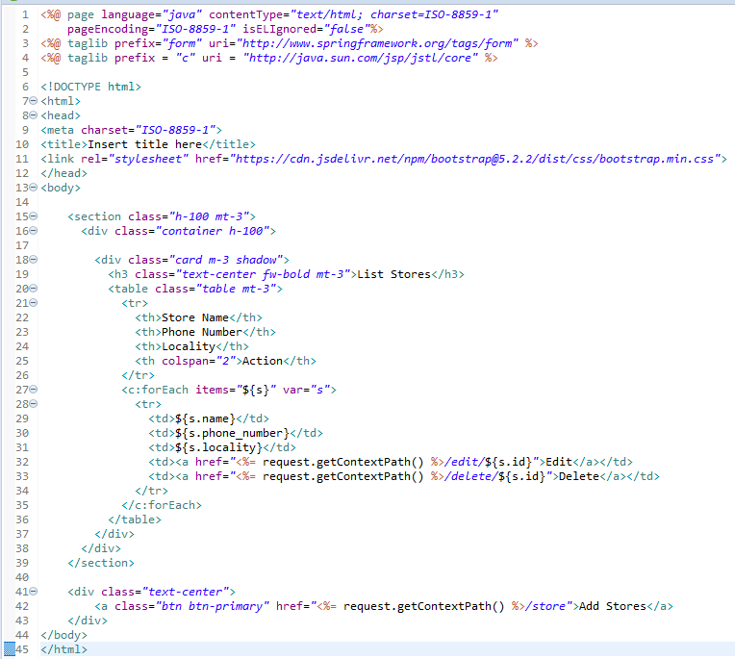**
  3. **Ensure that view stores request works end-to-end. (i.e., should be able to submit request to view the stores in the browser and get the page back with all stores).  
     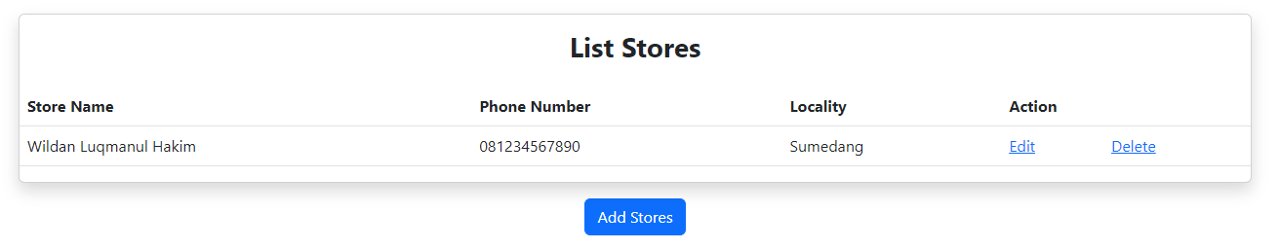**

1. **Create an HTML page to perform Add store, Fetch stores, Update store, & Delete store operations from the UI.  
   add-store.jsp  
   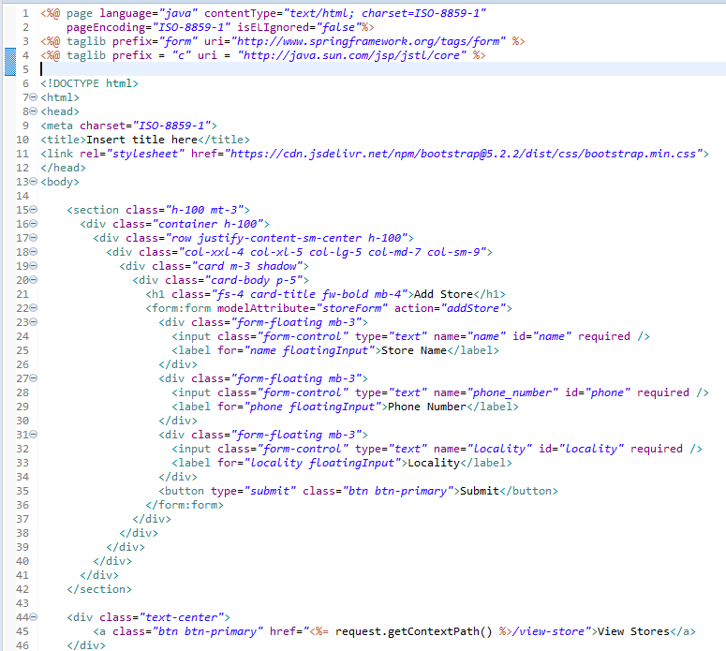**

**Add Store Page**

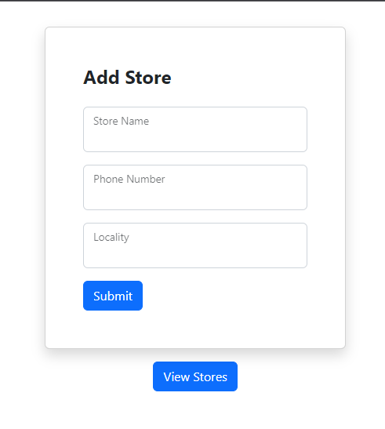

**store.jsp  
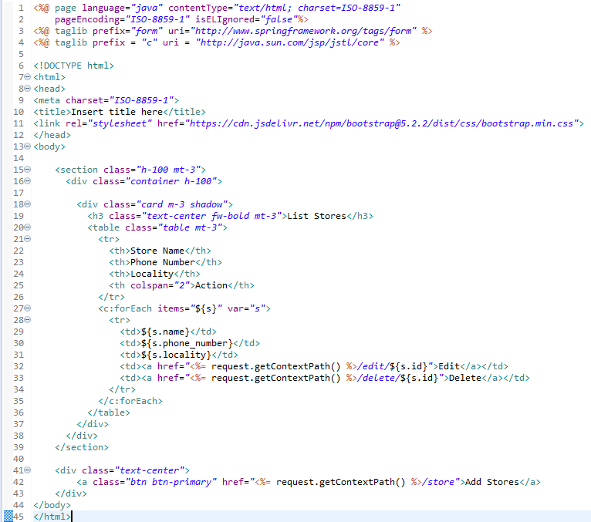**

**Store Page**

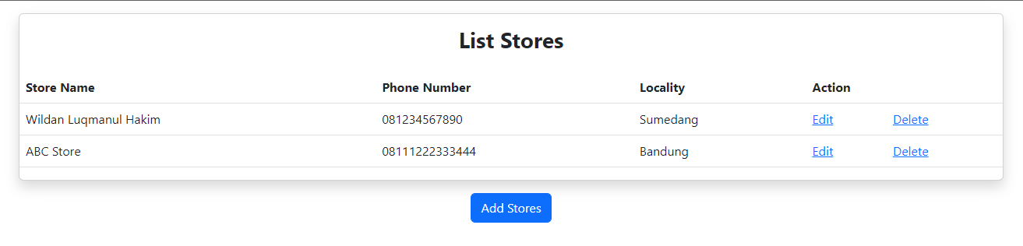

**edit-store.jsp  
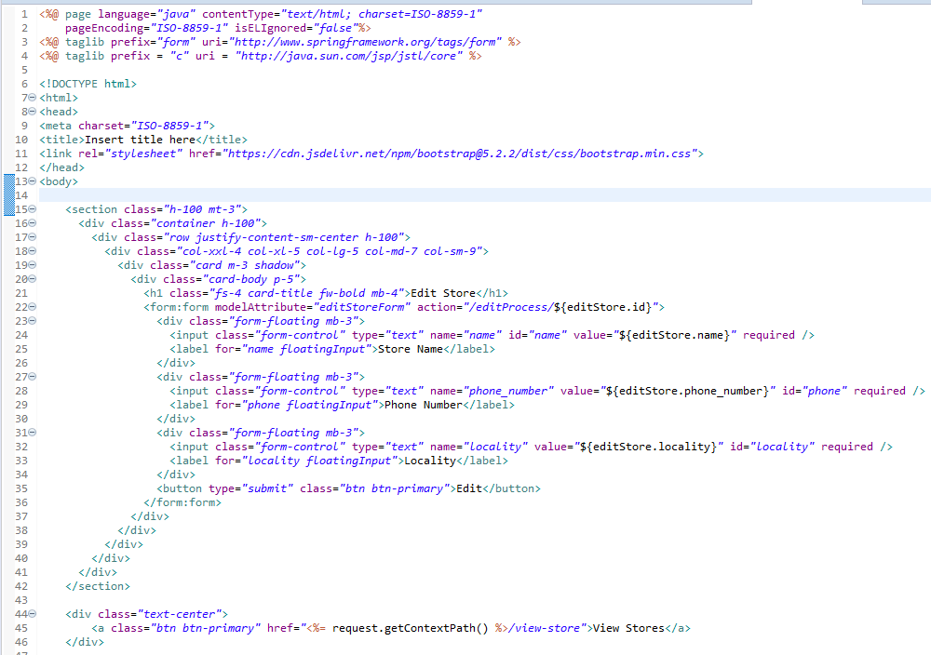  
  
Edit Store Page  
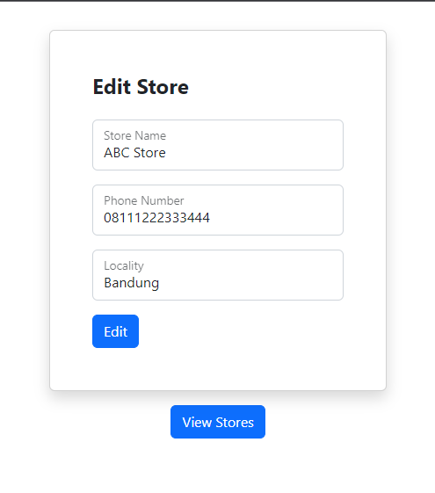**

Source Code :

